Basic Probability assignment for Axis Bank

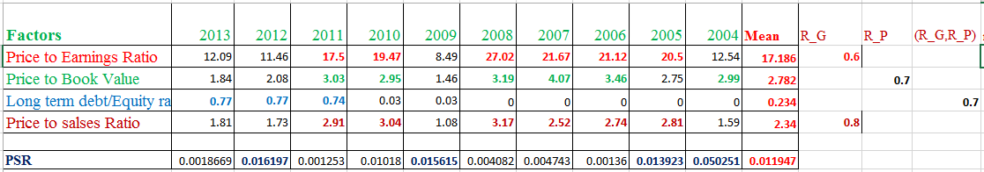

|  |  |  |  |
| --- | --- | --- | --- |
| No | Factors | Return | BPA |
| 1 | Price to Earnings Ratio | R_G | 0.6 |
| 2 | Price to Book Value | R_P | 0.7 |
| 3 | LTDER | R_G, R_P | 0.7 |
| 4 | Price to Sales Ratio | R_G | 0.8 |

Now ***for Factor 1(P/E),***

m1(R_G)=0.6

m1(ϴ)=1-0.6=0.4

***For Factor 2(P/B),***

m2 (R_P)=0.7

m2 (ϴ)=1-0.7=0.3

Combine factor 1 and factor 2

|  |  |  |
| --- | --- | --- |
| Combine Factor 1 with Factor 2 | m2 (R_P)=0.7 | m2 (ϴ)=0.3 |
| m1 (R_G)=0.6 | Φ=0.42 | R_G=0.18 |
| m1 (ϴ)=0.4 | R_P=0.28 | ϴ=0.12 |

m3(R_G)=0.18/(1-0.42)=0.3103

m3(R_P)=0.28/(1-0.42)=0.4827

m3(ϴ)=0.12/(1-0.42)=0.20689

***For Factor 3(LTDER)***

m4(R_G,R_P)=0.7

m4(ϴ)=1-0.7=0.3

Combine Factor 1, 2 and 3

|  |  |  |
| --- | --- | --- |
| Combine Factor 1, 2 and 3 | m4(R_G,R_P)=0.7 | m4(ϴ)=0.3 |
| m3(R_G)=0.3103 | R_G=0.2172 | R_G=0.09309 |
| m3(R_P)=0.4827 | R_P=0.33789 | R_P=0.14481 |
| m3(ϴ)=0.20689 | (R_G,R_P)=0.14482 | ϴ=0.0618 |

m5**(**R_G)=(0.2172+0.09309)/(1-0)=0.31029

m5**(**R_P)=(0.33789+0.14481)/(1-0)=0.4827

m5**(**R_G,R_P)=0.14482/(1-0)=0.14482

m5**(**ϴ)=0.0618/(1-0)=0.0618

***For Factor 4(P/S*)**

m6(R_G)=0.8

m6(ϴ)=1-0.8=0.2

Combine Factor 1, 2, 3 and 4

|  |  |  |
| --- | --- | --- |
| Combine Factor 1,2,3 and 4 | m6(R_G)=0.8 | m6(ϴ)=0.2 |
| m5**(**R_G)=0.31029 | R_G=0.2482 | R_G=0.062 |
| m5**(**R_P)=0.4827 | Φ=0.3861 | R_P=0.0965 |
| m5**(**R_G,R_P)=0.14482 | R_G=0.11585 | (R_G,R_P)=0.0289 |
| m5**(**ϴ)=0.0618 | R_G=0.04944 | ϴ=0.01236 |

***m7(R_G)=(0.2482+0.062+0.11585+0.04944)/(1-0.3861)=0.7744***

m7**(**R_P)=0.0965/(1-0.3861)=0.157

m7**(**R_G**,**R_P)=0.0289/(1-0.3861)=0.047

m7**(**ϴ)=0.01236/(1-0.3861)=0.0201

